**Mobile Computing**

**Assignment 2**

**Graphics and animation, Multimedia, Location Based Services**

1. **Aim:**Write a program to draw different shapes on canvas.

**Code:**

**activity_main.xml**

<?xml version="1.0" encoding="utf-8"?>

<LinearLayout xmlns:android="http://schemas.android.com/apk/res/android"

xmlns:app="http://schemas.android.com/apk/res-auto"

xmlns:tools="http://schemas.android.com/tools"

android:id="@+id/main"

android:layout_width="match_parent"

android:layout_height="match_parent"

android:orientation="vertical"

tools:context=".MainActivity">

</LinearLayout>

**MainActivity.java**

package com.example.paint_siddhi;

import androidx.appcompat.app.AppCompatActivity;

import android.content.Context;

import android.graphics.Canvas;

import android.graphics.Color;

import android.graphics.Paint;

import android.os.Bundle;

import android.view.View;

public class MainActivity extends AppCompatActivity {

@Override

protected void onCreate(Bundle savedInstanceState) {

super.onCreate(savedInstanceState);

setContentView(new myview(this));

}

}

class myview extends View {

public myview(Context context) {

super(context);

}

public void onDraw(Canvas canvas){

super.onDraw(canvas);

Paint paint = new Paint();

paint.setStyle(Paint.Style.FILL);

paint.setColor(Color.YELLOW);

canvas.drawCircle(600,350,250,paint);

paint.setColor(Color.GREEN);

paint.setTextSize(60);

canvas.drawText("Graphics Example",40,50,paint);

canvas.drawRect(100,400,300,100,paint);

}

}

**Output:**

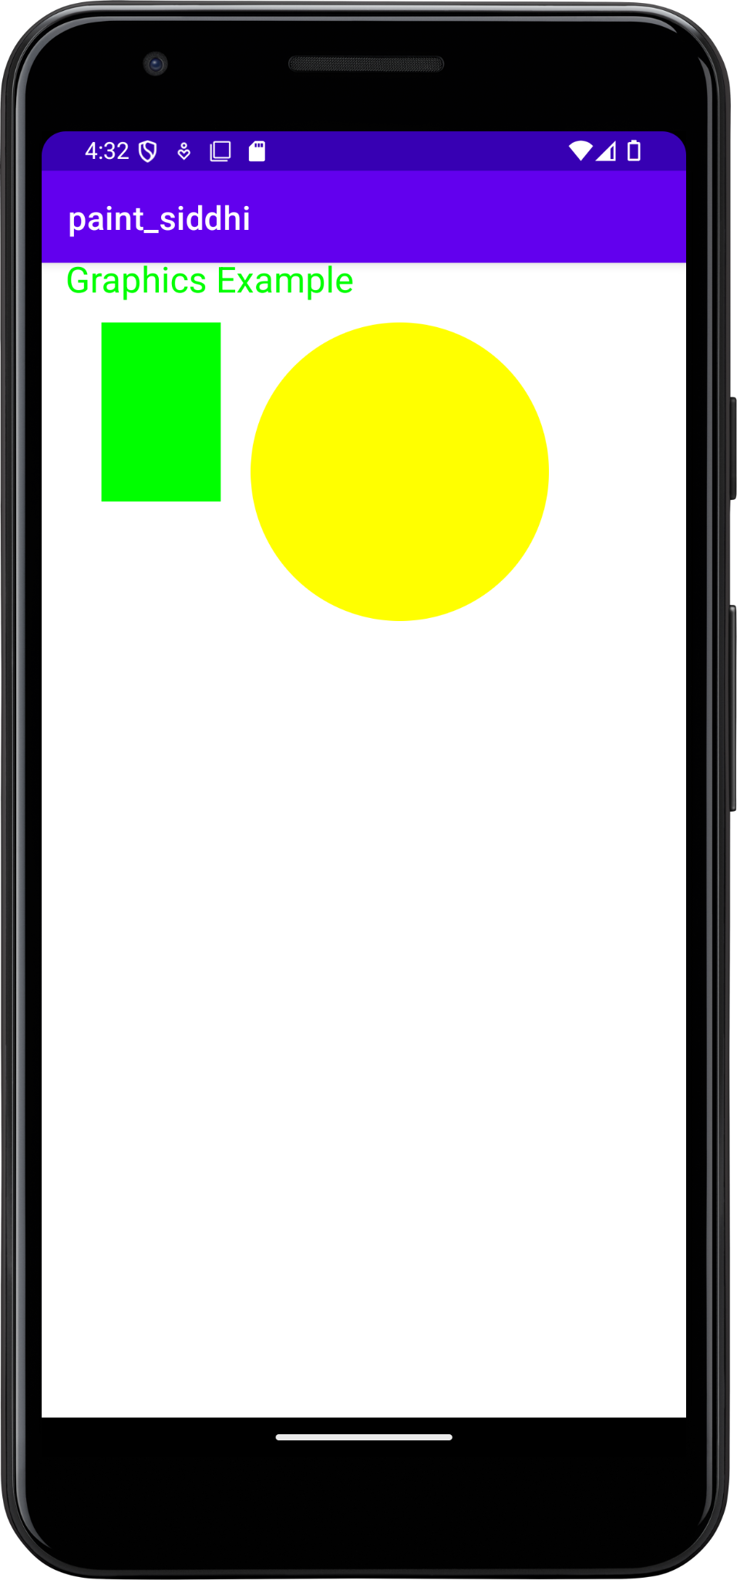

1. **Aim:**Write a program to play audio.

**Code:**

**Activity.xml**

<?xml version="1.0" encoding="utf-8"?>

<LinearLayout xmlns:android="http://schemas.android.com/apk/res/android"

xmlns:app="http://schemas.android.com/apk/res-auto"

xmlns:tools="http://schemas.android.com/tools"

android:layout_width="match_parent"

android:layout_height="match_parent"

android:orientation="horizontal"

android:gravity="center"

tools:context=".MainActivity">

<Button

android:id="@+id/start"

android:layout_width="wrap_content"

android:layout_height="wrap_content"

android:text="Start"

android:onClick="startMusic" />

<Button

android:id="@+id/stop"

android:layout_width="wrap_content"

android:layout_height="wrap_content"

android:onClick="stopMusic"

android:layout_marginStart="50dp"

android:text="Stop" />

</LinearLayout>

**MainActivity.java**

package com.example.practical1_module2;

import androidx.appcompat.app.AppCompatActivity;

import android.content.Intent;

import android.os.Bundle;

import android.view.View;

import android.widget.Button;

public class MainActivity extends AppCompatActivity {

Button start,stop;

@Override

protected void onCreate(Bundle savedInstanceState) {

super.onCreate(savedInstanceState);

setContentView(R.layout.activity_main2);

start = findViewById(R.id.start);

stop = findViewById(R.id.stop);

}

public void startMusic(View view){

Intent intent = new Intent(this,musicService.class);

startService(intent);

}

public void stopMusic(View view){

Intent intent = new Intent(this,musicService.class);

stopService(intent);

}

}

musicService.java

package com.example.practical1_module2;

import android.app.Service;

import android.content.Intent;

import android.media.MediaPlayer;

import android.os.IBinder;

import android.widget.Toast;

public class musicService extends Service {

MediaPlayer player;

@Override

public int onStartCommand(Intent intent, int flags, int startId) {

player = MediaPlayer.create(this,R.raw.music);

player.setLooping(true);

player.start();

Toast.makeText(this, "Music is Started", Toast.LENGTH_SHORT).show();

return START_STICKY;

}

public void onDestroy(){

super.onDestroy();

player.stop();

Toast.makeText(this, "Stopped", Toast.LENGTH_SHORT).show();

}

public musicService() {

}

@Override

public IBinder onBind(Intent intent) {

// TODO: Return the communication channel to the service.

throw new UnsupportedOperationException("Not yet implemented");

}

}

**Output:**

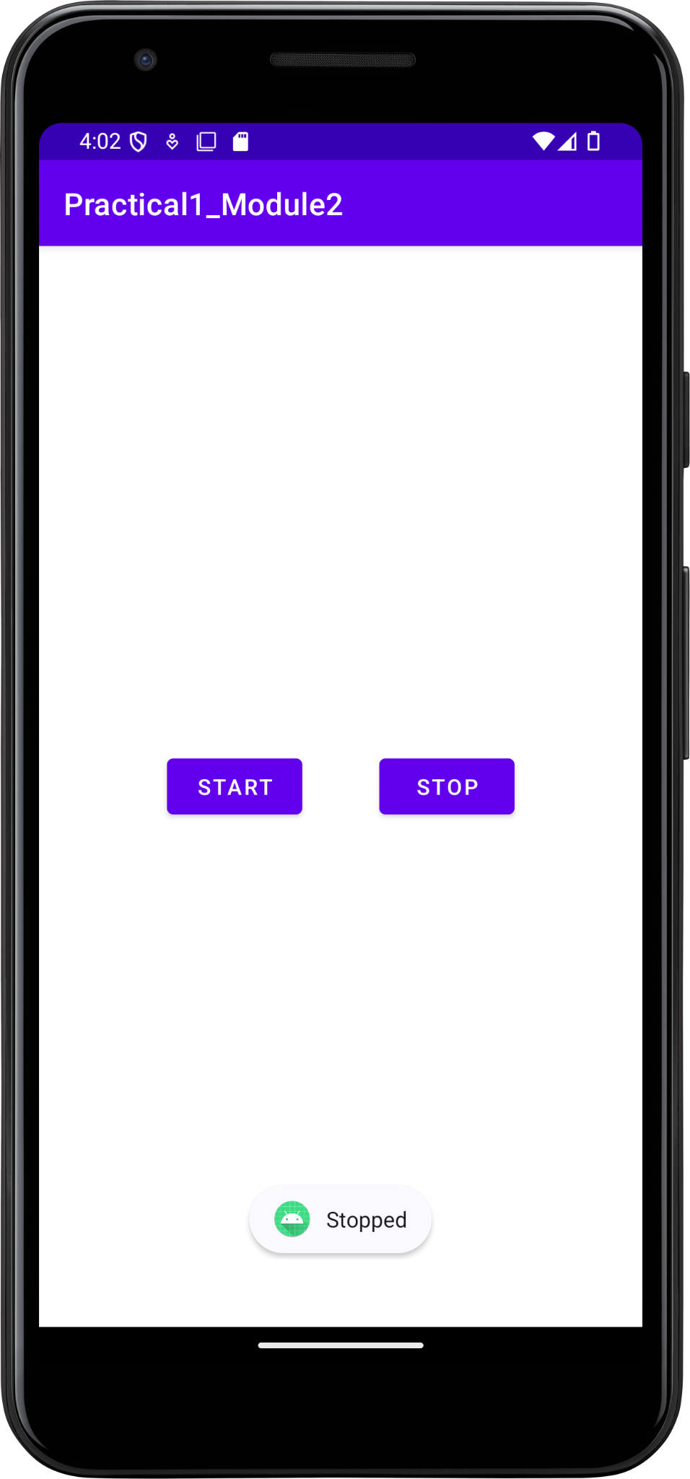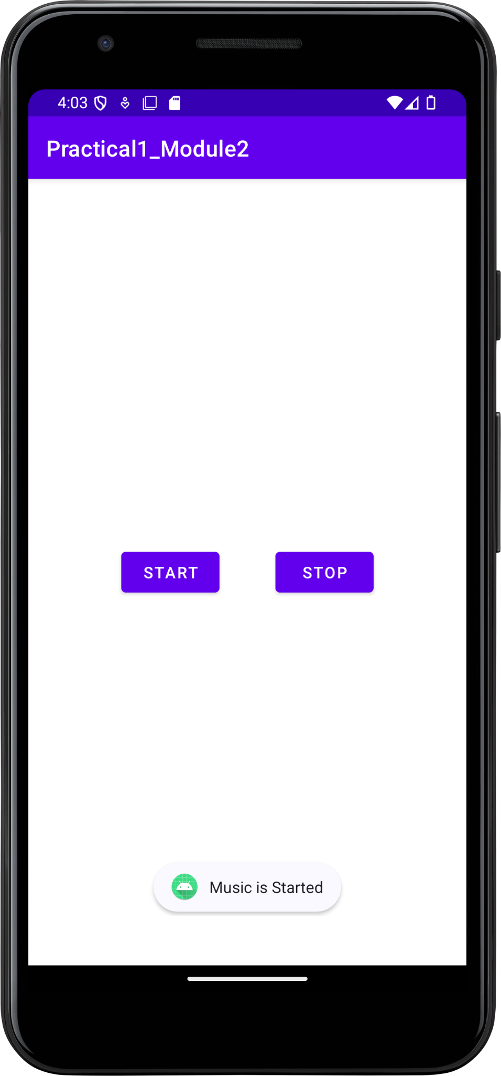

1. **Aim:**Write a program to play video.

**Code:**

**activity_main.xml**

<?xml version="1.0" encoding="utf-8"?>

<RelativeLayout xmlns:android="http://schemas.android.com/apk/res/android"

xmlns:app="http://schemas.android.com/apk/res-auto"

xmlns:tools="http://schemas.android.com/tools"

android:layout_width="match_parent"

android:layout_height="match_parent"

tools:context=".MainActivity">

<VideoView

android:layout_width="match_parent"

android:layout_height="match_parent"

android:id="@+id/videoview1"

android:layout_alignParentLeft="true"

android:layout_centerVertical="true">

</VideoView>

</RelativeLayout>

**MainActivity.java**

package com.example.siddhi_video;

import androidx.appcompat.app.AppCompatActivity;

import android.net.Uri;

import android.os.Bundle;

import android.widget.MediaController;

import android.widget.VideoView;

public class MainActivity extends AppCompatActivity {

@Override

protected void onCreate(Bundle savedInstanceState) {

super.onCreate(savedInstanceState);

setContentView(R.layout.activity_main);

VideoView videoview = findViewById(R.id.videoview1);

String path = "android.resource://"+getPackageName()+"/"+R.raw.videoplayback;

Uri url = Uri.parse(path);

videoview.setVideoURI(url);

MediaController mediaController = new MediaController(this);

videoview.setMediaController(mediaController);

mediaController.setAnchorView(videoview);

}

}

**Output:**

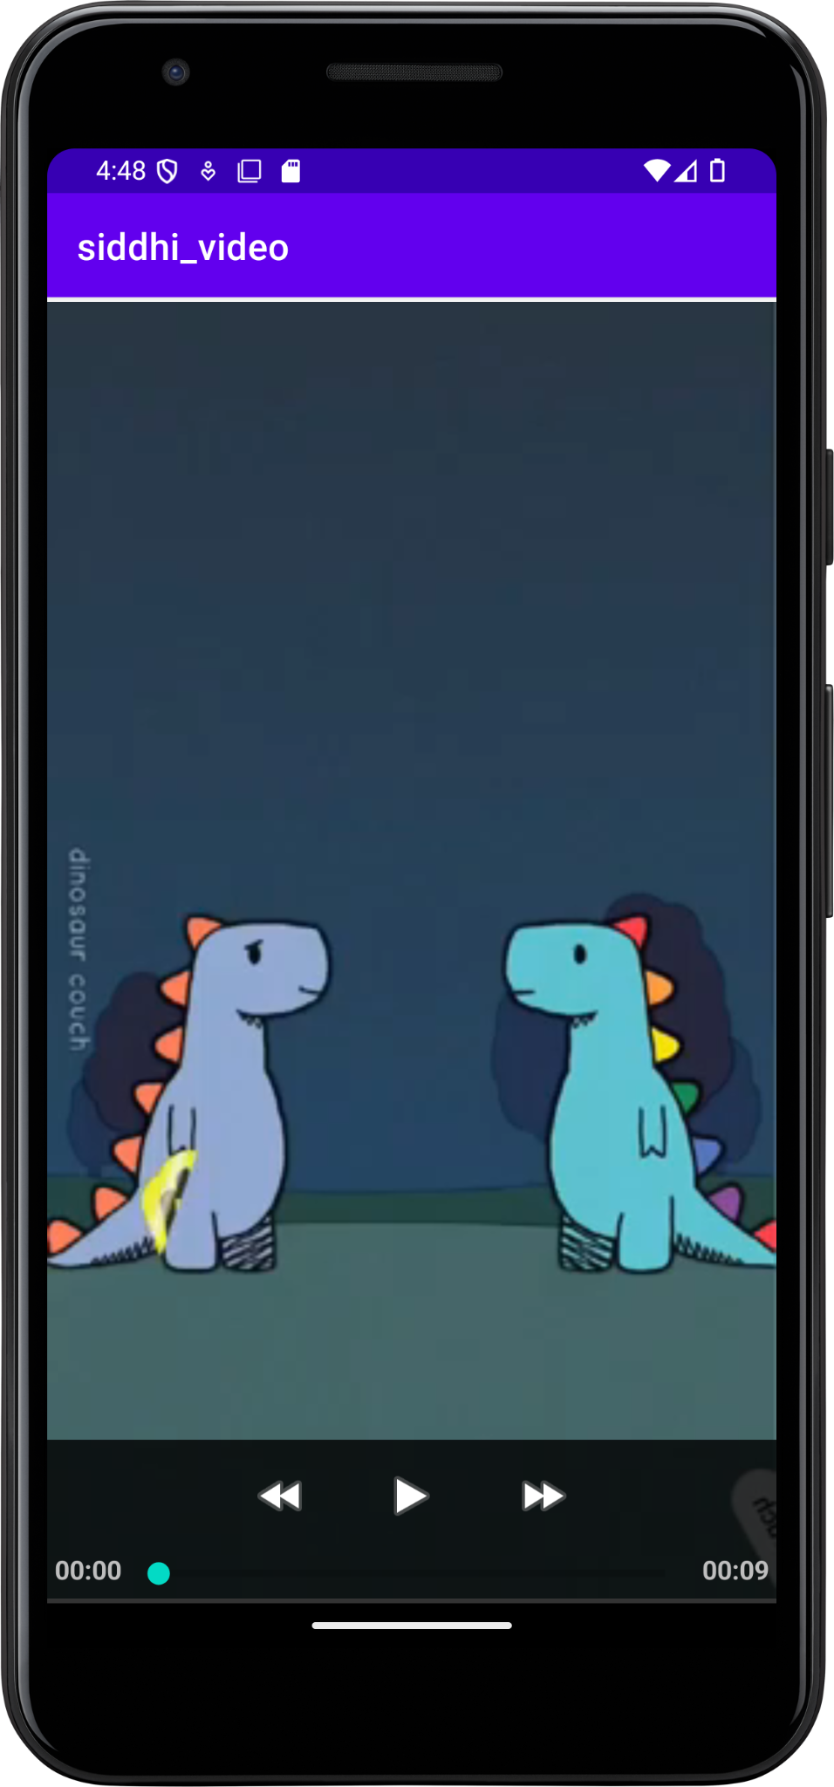

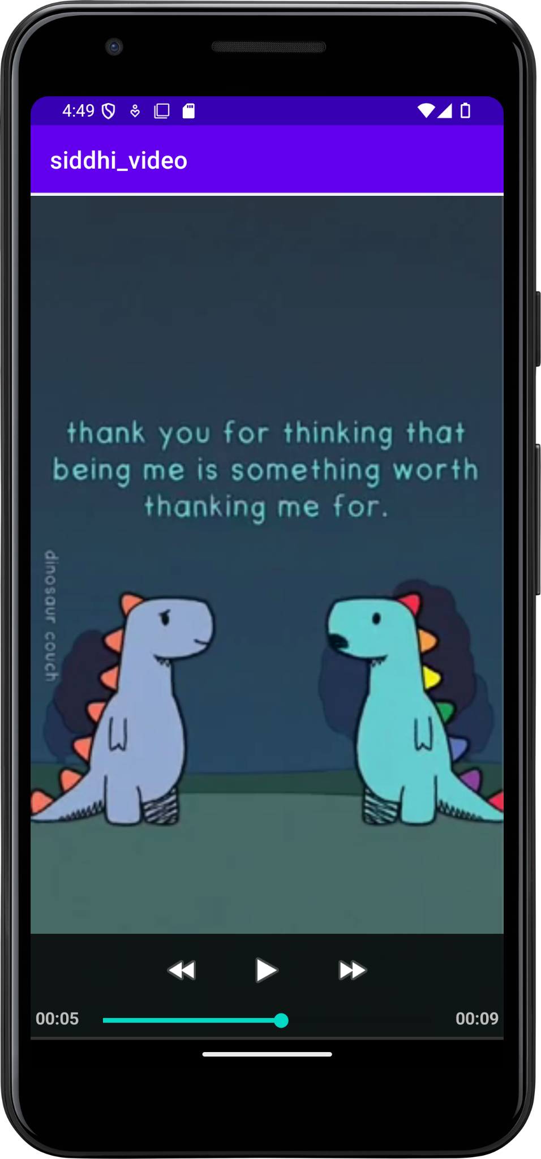

1. **Aim:**Write a program to perform frame by frame animation.

**Code:**

**activity_main.xml**

<?xml version="1.0" encoding="utf-8"?>

<LinearLayout xmlns:android="http://schemas.android.com/apk/res/android"

xmlns:app="http://schemas.android.com/apk/res-auto"

xmlns:tools="http://schemas.android.com/tools"

android:layout_width="match_parent"

android:layout_height="match_parent"

android:orientation="vertical"

tools:context=".MainActivity">

<ImageView

android:id="@+id/image"

android:layout_width="match_parent"

android:layout_height="wrap_content"

android:src="@drawable/one"

tools:ignore="ContentDescription" />

<TextView

android:id="@+id/textView"

android:layout_width="wrap_content"

android:layout_height="wrap_content"

android:text="Siddhi Kotre"

android:textSize="36dp"

tools:ignore="HardcodedText,SpUsage" />

<Button

android:id="@+id/button"

android:layout_width="wrap_content"

android:layout_height="wrap_content"

android:text="START"

android:onClick="startAnimation"

tools:ignore="HardcodedText" />

<Button

android:id="@+id/button2"

android:layout_width="wrap_content"

android:layout_height="wrap_content"

android:text="STOP"

android:onClick="stopAnimation"

tools:ignore="HardcodedText" />

</LinearLayout>

**MainActivity.java**

package com.example.myapplication;

import android.os.Bundle;

import androidx.appcompat.app.AppCompatActivity;

import android.graphics.drawable.AnimationDrawable;

import android.os.Bundle;

import android.view.View;

import android.widget.ImageView;

public class MainActivity extends AppCompatActivity {

ImageView img;

AnimationDrawable animation;

@Override

protected void onCreate(Bundle savedInstanceState) {

super.onCreate(savedInstanceState);

setContentView(R.layout.activity_main);

img = findViewById(R.id.image);

img.setImageResource(R.drawable.running);

animation = (AnimationDrawable) img.getDrawable();

}

public void startAnimation(View view){

animation.start();

}

public void stopAnimation(View view){

animation.stop();

}

}

**Running.xml**

<?xml version="1.0" encoding="utf-8"?>

<animation-list xmlns:android="http://schemas.android.com/apk/res/android">

<item android:drawable="@drawable/one" android:duration="100"/>

<item android:drawable="@drawable/two" android:duration="100"/>

<item android:drawable="@drawable/three" android:duration="100" />

<item android:drawable="@drawable/four" android:duration="100"/>

</animation-list>

**Output:**

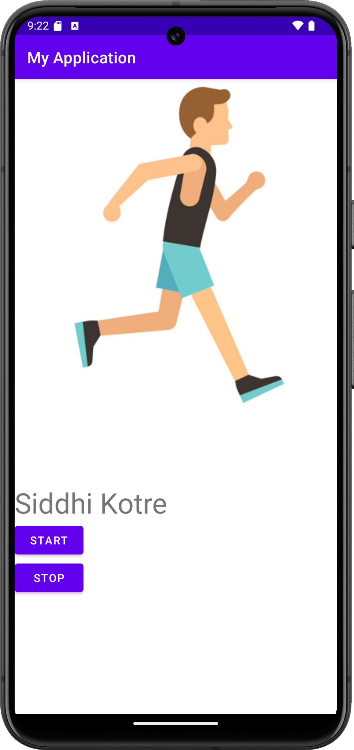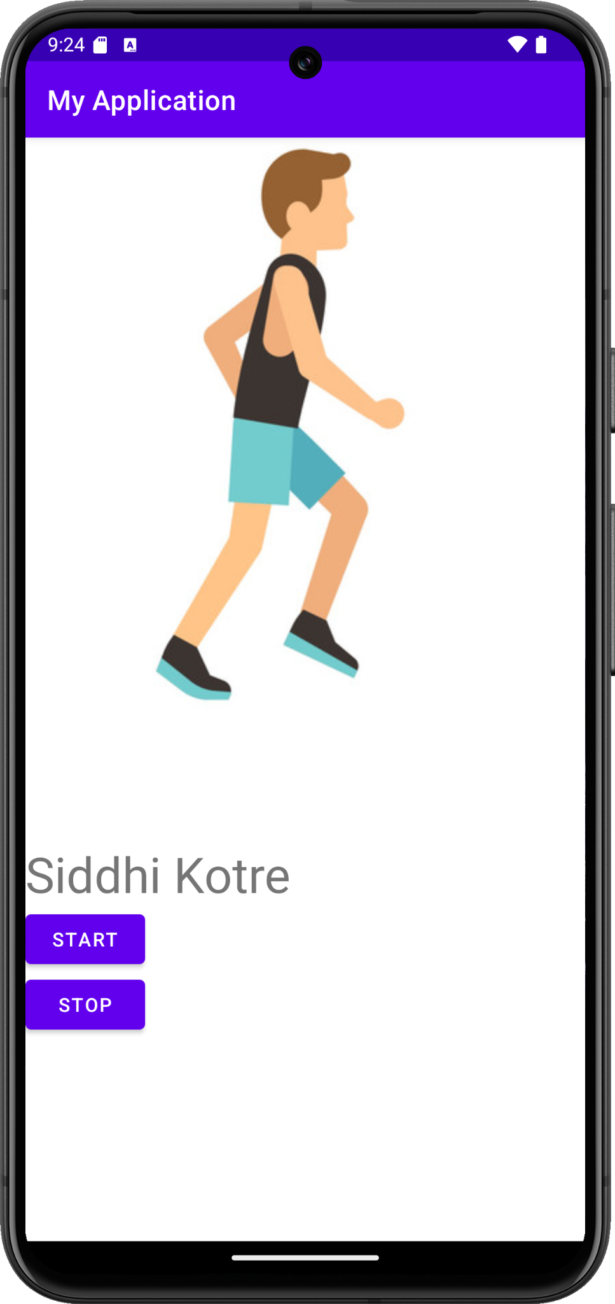

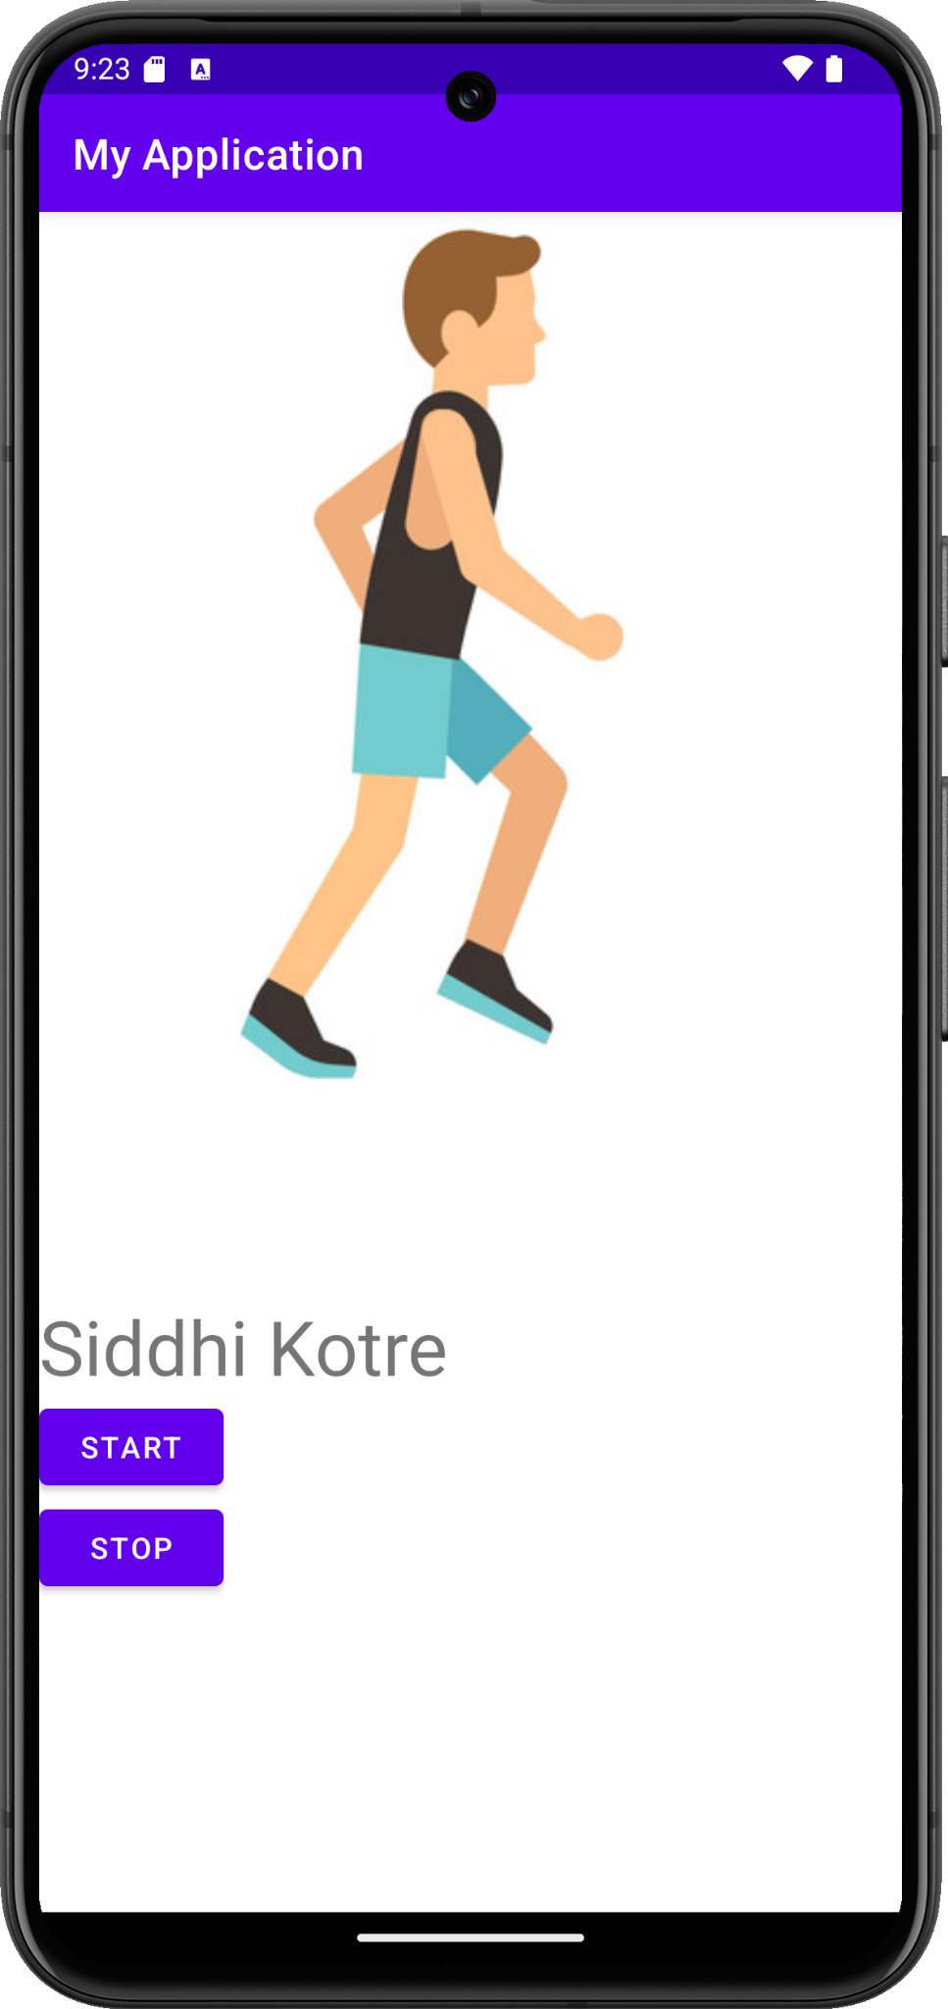

1. **Aim:**Write a program to perform different operations on image (i.e. rotation, expand, shrink, move and set)

**Code:**

**activity_main.xml**

<?xml version="1.0" encoding="utf-8"?>

<LinearLayout xmlns:android="http://schemas.android.com/apk/res/android"

xmlns:app="http://schemas.android.com/apk/res-auto"

xmlns:tools="http://schemas.android.com/tools"

android:layout_width="match_parent"

android:layout_height="match_parent"

android:orientation="vertical"

tools:context=".MainActivity">

<ImageView

android:id="@+id/imageView"

android:layout_width="264dp"

android:layout_height="311dp"

android:layout_marginStart="72dp"

android:layout_marginTop="50dp"

app:layout_constraintStart_toStartOf="parent"

app:layout_constraintTop_toTopOf="parent"

app:srcCompat="@drawable/image1"

tools:ignore="ContentDescription" />

<Button

android:id="@+id/button"

android:layout_width="wrap_content"

android:layout_height="wrap_content"

android:text="FADE"

android:layout_marginTop="15dp"

android:layout_marginLeft="6dp"

android:onClick="fade"

tools:ignore="HardcodedText,RtlHardcoded" />

<Button

android:id="@+id/button2"

android:layout_width="wrap_content"

android:layout_height="wrap_content"

android:text="ROTATE"

android:layout_marginTop="-48dp"

android:layout_marginLeft="155dp"

android:onClick="rotate"

tools:ignore="HardcodedText,RtlHardcoded" />

<Button

android:id="@+id/button3"

android:layout_width="wrap_content"

android:layout_height="wrap_content"

android:text="EXPAND"

android:layout_marginTop="-48dp"

android:layout_marginLeft="290dp"

android:onClick="expand"

tools:ignore="HardcodedText,RtlHardcoded" />

<Button

android:id="@+id/button4"

android:layout_width="wrap_content"

android:layout_height="wrap_content"

android:text="SET"

android:layout_marginTop="10dp"

android:layout_marginLeft="100dp"

android:onClick="set"

tools:ignore="HardcodedText,RtlHardcoded" />

<Button

android:id="@+id/button5"

android:layout_width="wrap_content"

android:layout_height="wrap_content"

android:text="MOVE"

android:layout_marginTop="-48dp"

android:layout_marginLeft="240dp"

android:onClick="move"

tools:ignore="HardcodedText,RtlHardcoded" />

<TextView

android:id="@+id/textView"

android:layout_width="match_parent"

android:layout_height="wrap_content"

android:text="Siddhi Kotre"

android:textSize="36dp"

tools:ignore="HardcodedText,SpUsage" />

</LinearLayout>

**MainActivity.java**

package com.example.myapplication;

import android.os.Bundle;

import androidx.appcompat.app.AppCompatActivity;

import android.graphics.drawable.AnimationDrawable;

import android.os.Bundle;

import android.view.View;

import android.view.animation.Animation;

import android.view.animation.AnimationUtils;

import android.widget.ImageView;

public class MainActivity extends AppCompatActivity {

ImageView img;

@Override

protected void onCreate(Bundle savedInstanceState) {

super.onCreate(savedInstanceState);

setContentView(R.layout.activity_main);

img=findViewById(R.id.imageView);

}

public void fade(View view){

Animation fade = AnimationUtils.loadAnimation(getApplicationContext(),R.anim.fade);

img.startAnimation(fade);

}

public void rotate(View view){

Animation rotate = AnimationUtils.loadAnimation(getApplicationContext(),R.anim.rotate);

img.startAnimation(rotate);

}

public void expand(View view){

Animation expand = AnimationUtils.loadAnimation(getApplicationContext(),R.anim.expand);

img.startAnimation(expand);

}

public void set(View view){

Animation set = AnimationUtils.loadAnimation(getApplicationContext(),R.anim.set);

img.startAnimation(set);

}

public void move(View view){

Animation move = AnimationUtils.loadAnimation(getApplicationContext(),R.anim.move);

img.startAnimation(move);

}

}

**fade.xml**

<?xml version="1.0" encoding="utf-8"?>

<set xmlns:android="http://schemas.android.com/apk/res/android">

<alpha

android:fromAlpha="0"

android:toAlpha="1"

android:duration="5000"

/>

</set>

**rotate.xml**

<?xml version="1.0" encoding="utf-8"?>

<set xmlns:android="http://schemas.android.com/apk/res/android">

<rotate

android:duration="1500"

android:fromDegrees="300"

android:toDegrees="0"

android:pivotX="90%"

android:pivotY="50%"

android:repeatCount="0"

/>

</set>

**expand.xml**

<?xml version="1.0" encoding="utf-8"?>

<set xmlns:android="http://schemas.android.com/apk/res/android">

<scale

android:fromXScale="0"

android:toXScale="1"

android:fromYScale="0"

android:toYScale="1"

android:pivotY="50%"

android:pivotX="50%"

android:duration="2000"

/>

</set>

**set.xml**

<?xml version="1.0" encoding="utf-8"?>

<set xmlns:android="http://schemas.android.com/apk/res/android">

<scale

android:fromXScale="0"

android:toXScale="1"

android:fromYScale="0"

android:toYScale="1"

android:pivotY="50%"

android:pivotX="50%"

android:duration="2000"

/>

<rotate

android:duration="2000"

android:fromDegrees="300"

android:toDegrees="0"

android:pivotX="90%"

android:pivotY="50%"

android:repeatCount="0"

/>

</set>

**move.xml**

<?xml version="1.0" encoding="utf-8"?>

<set xmlns:android="http://schemas.android.com/apk/res/android">

<translate

android:fromYDelta="0"

android:toYDelta="150%"

android:duration="2000"

/>

</set>

**Output:**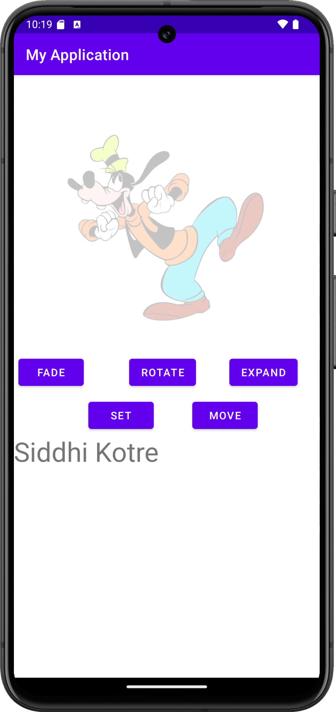

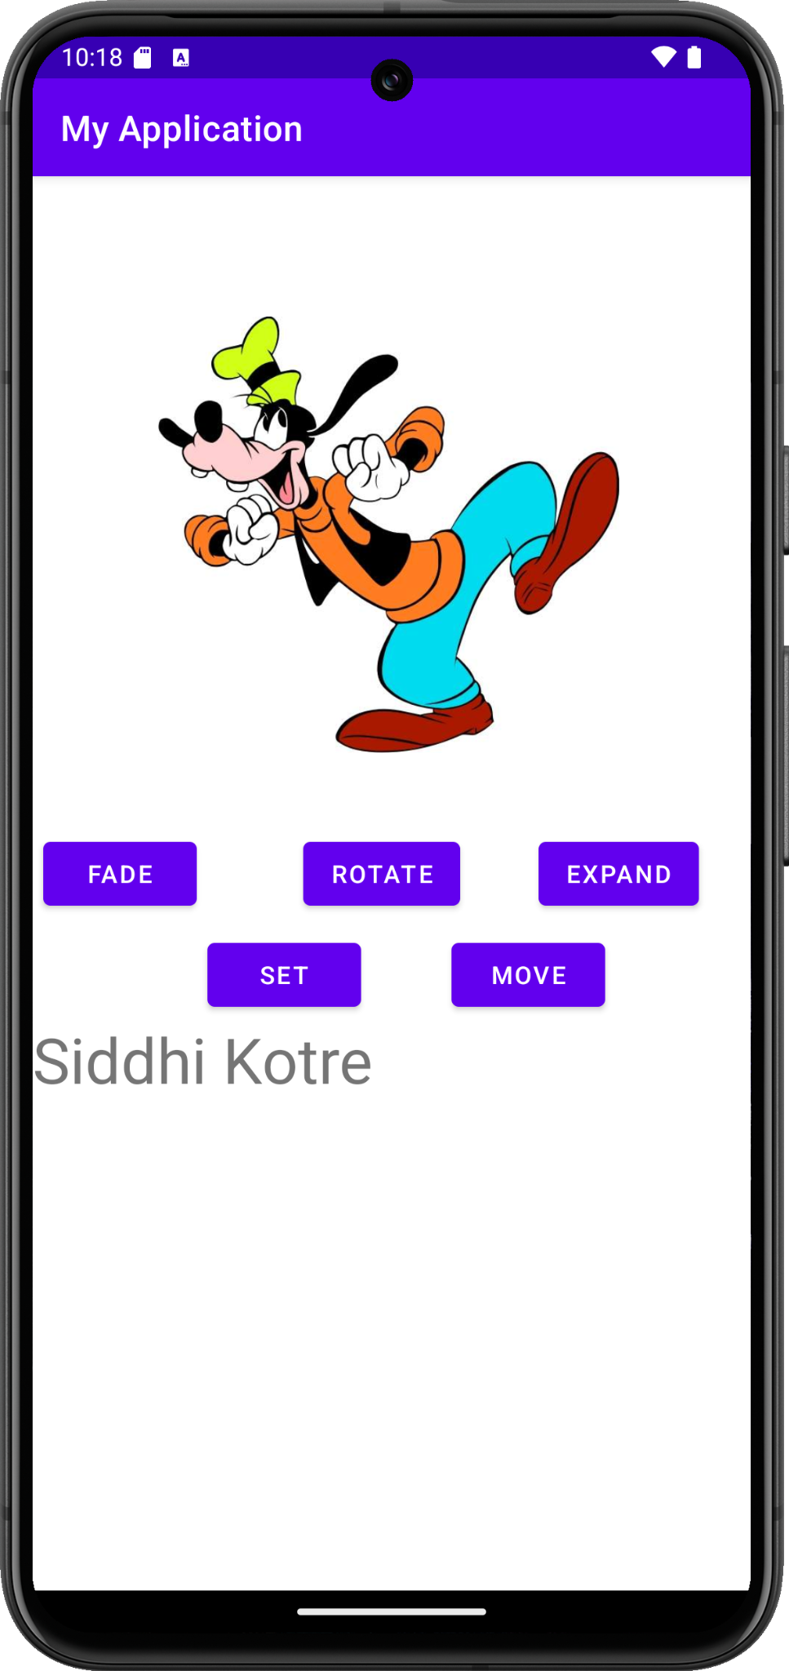

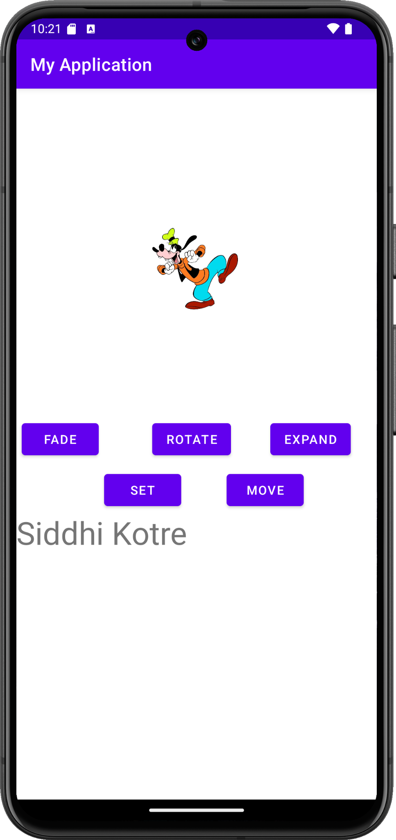

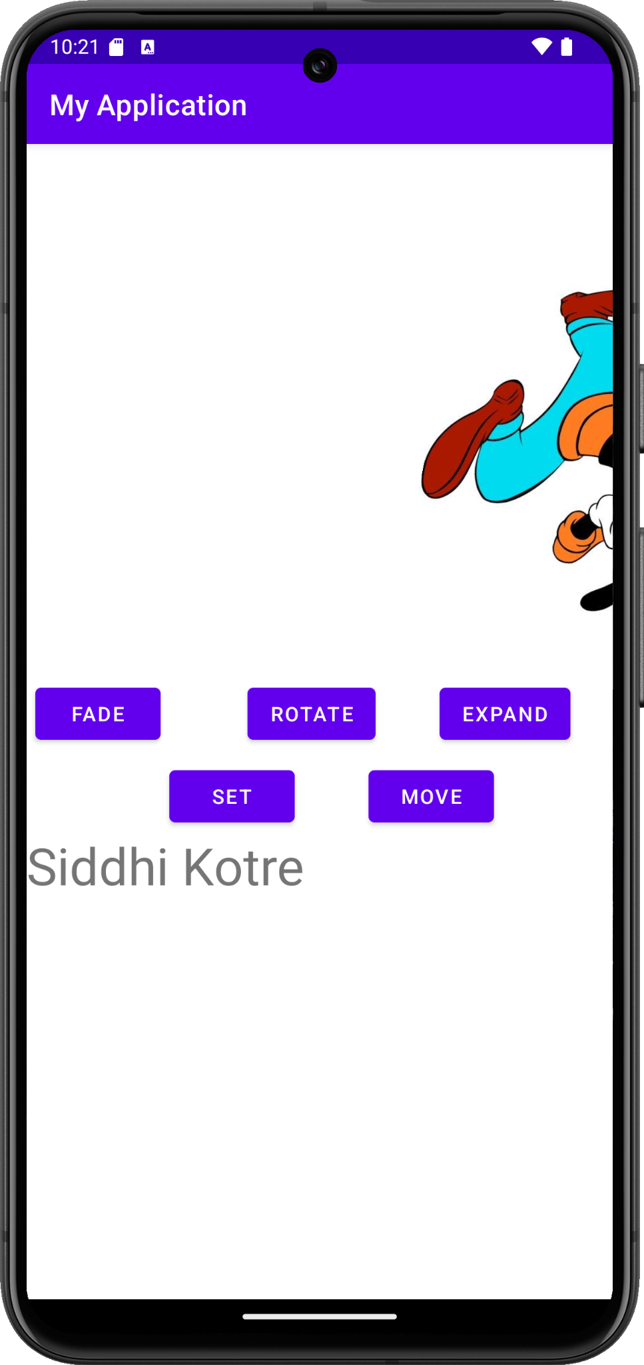

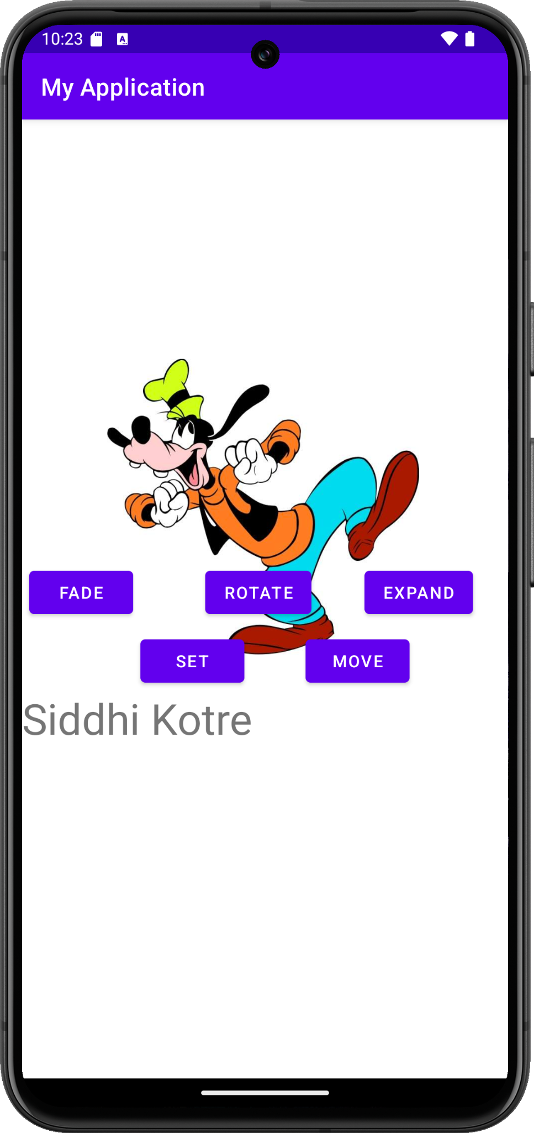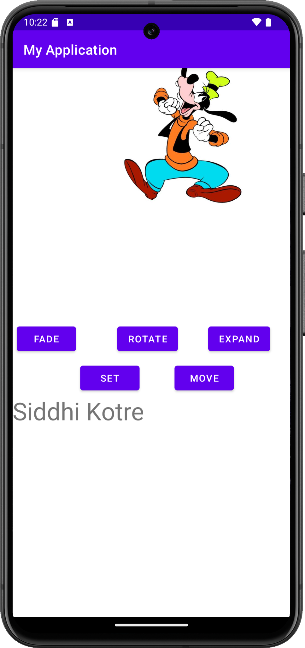

1. **Aim:**Write a program to fetch device longitude and latitude.

**Code:**

**AndroidManifest.xml**

<?xml version="1.0" encoding="utf-8"?>

<manifest xmlns:android="http://schemas.android.com/apk/res/android"

xmlns:tools="http://schemas.android.com/tools">

<uses-permission android:name="android.permission.ACCESS_COARSE_LOCATION"/>

<uses-permission android:name="android.permission.ACCESS_FINE_LOCATION"/>

<uses-permission android:name="android.permission.INTERNET"/>

<application

android:allowBackup="true"

android:dataExtractionRules="@xml/data_extraction_rules"

android:fullBackupContent="@xml/backup_rules"

android:icon="@mipmap/ic_launcher"

android:label="@string/app_name"

android:roundIcon="@mipmap/ic_launcher_round"

android:supportsRtl="true"

android:theme="@style/Theme.Geolocation"

tools:targetApi="31">

<activity

android:name=".MainActivity"

android:exported="true">

<intent-filter>

<action android:name="android.intent.action.MAIN" />

<category android:name="android.intent.category.LAUNCHER" />

</intent-filter>

</activity>

</application>

</manifest>

**ACTIVITY_MAIN.XML**

<?xml version="1.0" encoding="utf-8"?>

<LinearLayout xmlns:android="http://schemas.android.com/apk/res/android"

android:layout_width="match_parent"

android:layout_height="match_parent"

android:orientation="vertical"

android:gravity="center">

<TextView

android:id="@+id/t1"

android:layout_width="wrap_content"

android:layout_height="wrap_content"

android:text="Hello"

android:textSize="24sp" />

<Button

android:id="@+id/fetch"

android:onClick="fetchLocation"

android:layout_width="wrap_content"

android:layout_height="wrap_content"

android:text="fetch" />

</LinearLayout>

**MAINACTIVITY.JAVA**

package com.example.geolocation;

import androidx.annotation.NonNull;

import androidx.appcompat.app.AppCompatActivity;

import androidx.core.app.ActivityCompat;

import androidx.core.content.ContextCompat;

import android.annotation.SuppressLint;

import android.app.Activity;

import android.content.Context;

import android.content.pm.PackageManager;

import android.location.Location;

import android.location.LocationListener;

import android.location.LocationManager;

import android.os.Bundle;

import android.view.View;

import android.widget.TextView;

import android.widget.Button;

public class MainActivity extends AppCompatActivity implements LocationListener {

TextView Coordinate;

Button FetchLocation;

LocationManager locationManager;

@Override

protected void onCreate(Bundle savedInstanceState) {

super.onCreate(savedInstanceState);

setContentView(R.layout.activity_main);

Coordinate = findViewById(R.id.t1);

FetchLocation = findViewById(R.id.fetch);

if(ContextCompat.checkSelfPermission(MainActivity.this,android.Manifest.permission.ACCESS_FINE_LOCATION) != PackageManager.PERMISSION_GRANTED) {

ActivityCompat.requestPermissions(MainActivity.this, new String[]{

android.Manifest.permission.ACCESS_FINE_LOCATION, android.Manifest.permission.INTERNET

}, 101);

}

}

public void fetchLocation(View view) {

try {

locationManager = (LocationManager) getSystemService(Context.LOCATION_SERVICE);

locationManager.requestLocationUpdates(LocationManager.NETWORK_PROVIDER, 500,5, MainActivity.this);

} catch (SecurityException se) {

se.printStackTrace();

}

}

@Override

public void onLocationChanged(@NonNull Location location) {

Coordinate.setText("Latitude: " + location.getLatitude() + " Longitude: " + location.getLongitude());

}

}

**Output:**

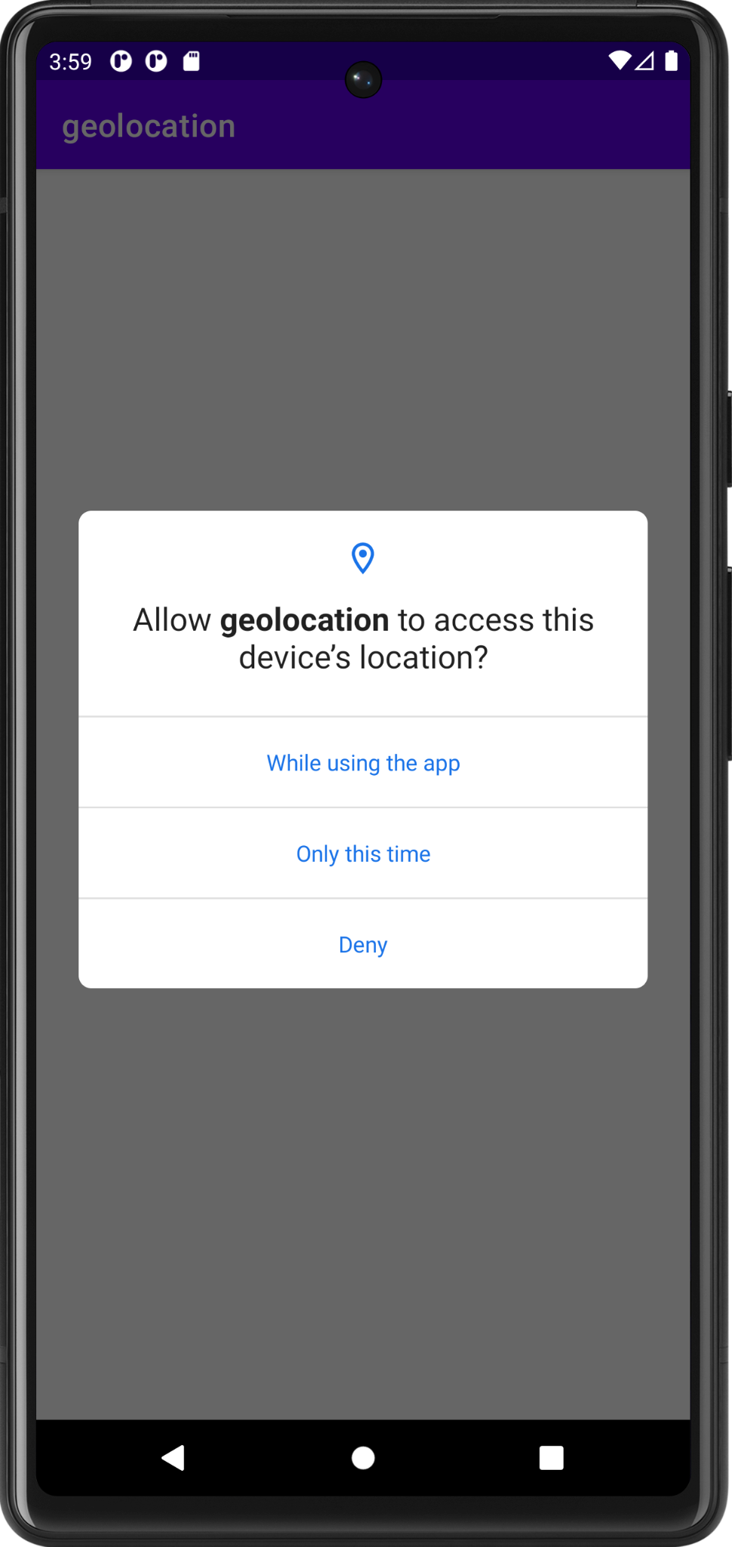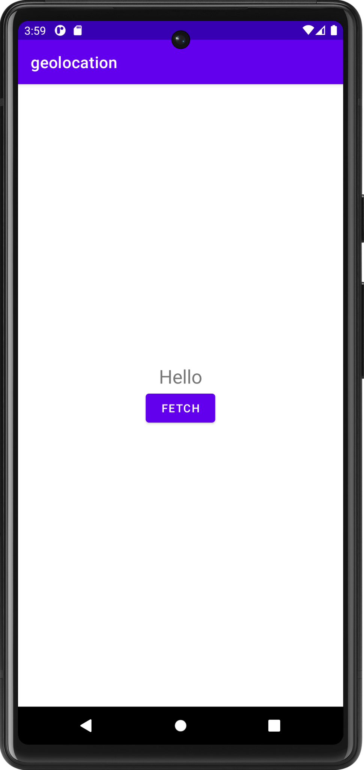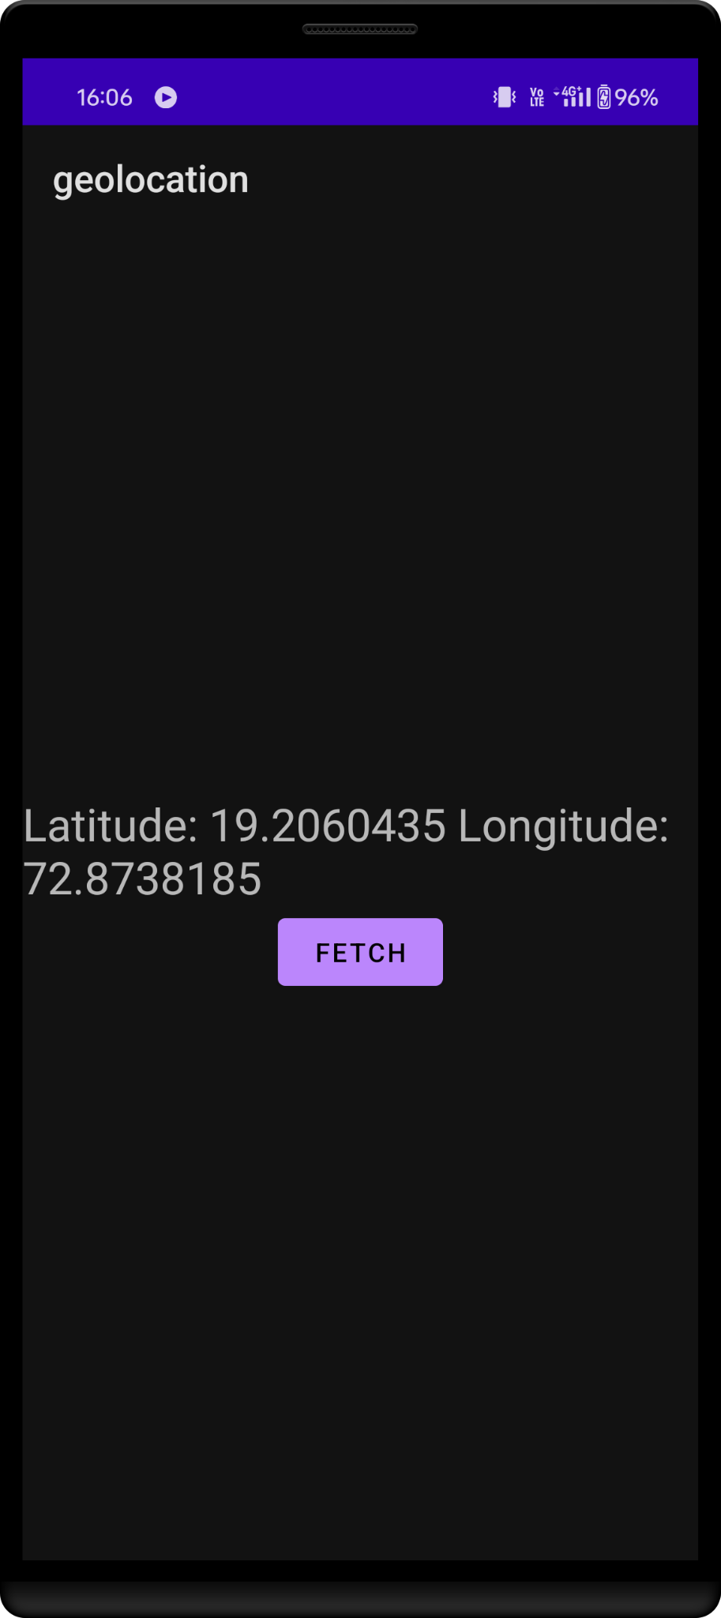

1. **Aim:**Write a program to fetch device current location from longitude and latitude (Reverse Geocoding).

**Code:**

**Activity_main.xml**

<?xml version="1.0" encoding="utf-8"?>

<LinearLayout xmlns:android="http://schemas.android.com/apk/res/android"

android:layout_width="match_parent"

android:layout_height="match_parent"

android:orientation="vertical"

android:gravity="center">

<TextView

android:id="@+id/t1"

android:layout_width="wrap_content"

android:layout_height="wrap_content"

android:text="Hello"

android:textSize="24sp" />

<Button

android:id="@+id/fetch"

android:onClick="fetchLocation"

android:layout_width="wrap_content"

android:layout_height="wrap_content"

android:text="fetch" />

</LinearLayout>

**MainActivity.java**

package com.example.geolocation;

import androidx.annotation.NonNull;

import androidx.appcompat.app.AppCompatActivity;

import androidx.core.app.ActivityCompat;

import androidx.core.content.ContextCompat;

import android.annotation.SuppressLint;

import android.app.Activity;

import android.content.Context;

import android.content.pm.PackageManager;

import android.location.Address;

import android.location.Geocoder;

import android.location.Location;

import android.location.LocationListener;

import android.location.LocationManager;

import android.os.Bundle;

import android.util.Log;

import android.view.View;

import android.widget.TextView;

import android.widget.Button;

import java.io.IOException;

import java.util.List;

import java.util.Locale;

public class MainActivity extends AppCompatActivity implements LocationListener {

TextView Coordinate;

Button FetchLocation;

LocationManager locationManager;

@Override

protected void onCreate(Bundle savedInstanceState) {

super.onCreate(savedInstanceState);

setContentView(R.layout.activity_main);

Coordinate = findViewById(R.id.t1);

FetchLocation = findViewById(R.id.fetch);

if(ContextCompat.checkSelfPermission(MainActivity.this,android.Manifest.permission.ACCESS_FINE_LOCATION) != PackageManager.PERMISSION_GRANTED) {

ActivityCompat.requestPermissions(MainActivity.this, new String[]{

android.Manifest.permission.ACCESS_FINE_LOCATION, android.Manifest.permission.INTERNET

}, 101);

}

}

public void fetchLocation(View view) {

try {

locationManager = (LocationManager) getSystemService(Context.LOCATION_SERVICE);

locationManager.requestLocationUpdates(LocationManager.NETWORK_PROVIDER, 500,5, MainActivity.this);

} catch (SecurityException se) {

se.printStackTrace();

}

}

@Override

public void onLocationChanged(@NonNull Location location) {

String address = GetLocation(location.getLatitude(),

location.getLongitude());

Coordinate.setText("Latitude: " + location.getLatitude() + " Longitude: " +

location.getLongitude()+"\n \n"+"Address"+address);

}

private String GetLocation(double latitude, double longitude){

String address="";

Geocoder geocoder = new Geocoder(this, Locale.getDefault());

try{

List<Address> addresses = geocoder.getFromLocation(latitude,longitude,1);

if(addresses!=null){

Address returnaddress=addresses.get(0);

Log.d("AddressLine", String.valueOf(returnaddress));

for(int i=0;i<= returnaddress.getMaxAddressLineIndex();i++){

address += returnaddress.getAddressLine(i)+"\n";

}

}

} catch (IOException e) {

throw new RuntimeException(e);

}

return address;

}

}

**Output:**

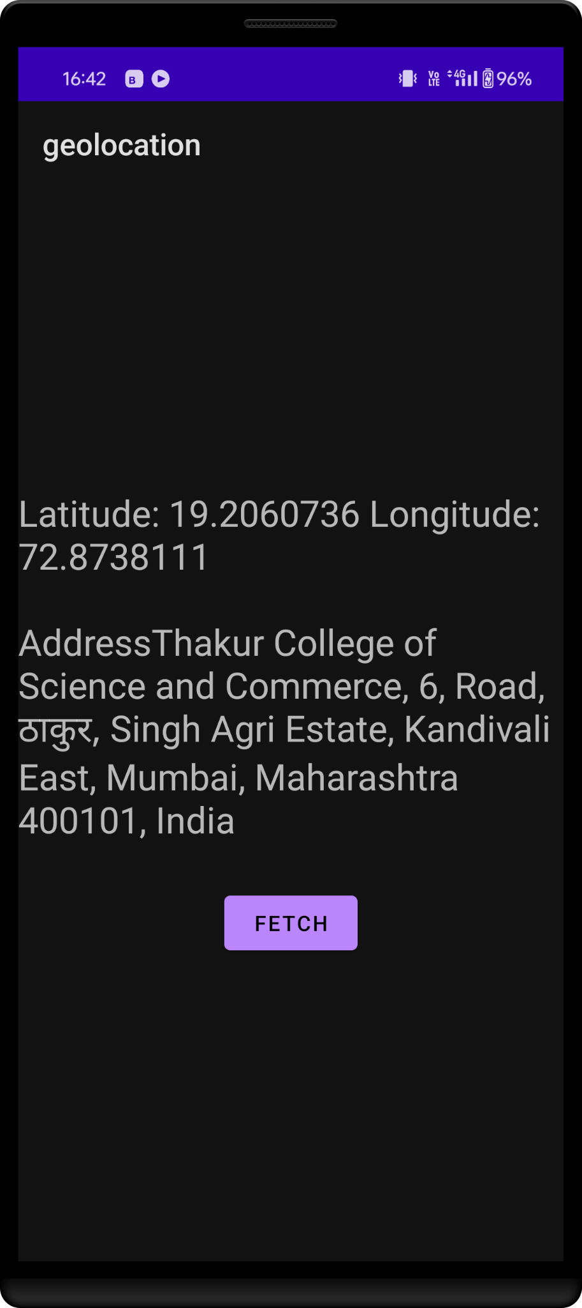

1. **Aim:**Write a program to add google maps and mark your state/area on a map.

**Code:**

**MapsActivity.java**

package com.example.maps;

import androidx.fragment.app.FragmentActivity;

import android.os.Bundle;

import com.google.android.gms.maps.CameraUpdateFactory;

import com.google.android.gms.maps.GoogleMap;

import com.google.android.gms.maps.OnMapReadyCallback;

import com.google.android.gms.maps.SupportMapFragment;

import com.google.android.gms.maps.model.LatLng;

import com.google.android.gms.maps.model.MarkerOptions;

import com.example.maps.databinding.ActivityMapsBinding;

public class MapsActivity extends FragmentActivity implements OnMapReadyCallback {

private GoogleMap mMap;

private ActivityMapsBinding binding;

@Override

protected void onCreate(Bundle savedInstanceState) {

super.onCreate(savedInstanceState);

binding = ActivityMapsBinding.inflate(getLayoutInflater());

setContentView(binding.getRoot());

// Obtain the SupportMapFragment and get notified when the map is ready to be used.

SupportMapFragment mapFragment = (SupportMapFragment) getSupportFragmentManager()

.findFragmentById(R.id.map);

mapFragment.getMapAsync(this);

}

@Override

public void onMapReady(GoogleMap googleMap) {

mMap = googleMap;

// Add a marker in Sydney and move the camera

LatLng siddhi= new LatLng(19.206166115736004, 72.8738085241981);

mMap.addMarker(new MarkerOptions().position(siddhi).title("Marker in Siddhi’s"));

mMap.moveCamera(CameraUpdateFactory.newLatLng(siddhi));

}

}

**activity_maps.xml**

<?xml version="1.0" encoding="utf-8"?>

<fragment xmlns:android="http://schemas.android.com/apk/res/android"

xmlns:map="http://schemas.android.com/apk/res-auto"

xmlns:tools="http://schemas.android.com/tools"

android:id="@+id/map"

android:name="com.google.android.gms.maps.SupportMapFragment"

android:layout_width="match_parent"

android:layout_height="match_parent"

tools:context=".MapsActivity" />

**Output:**

